GAMMA CHAPTER PAYPAL INSTRUCTIONS

Once you have a PayPal Account

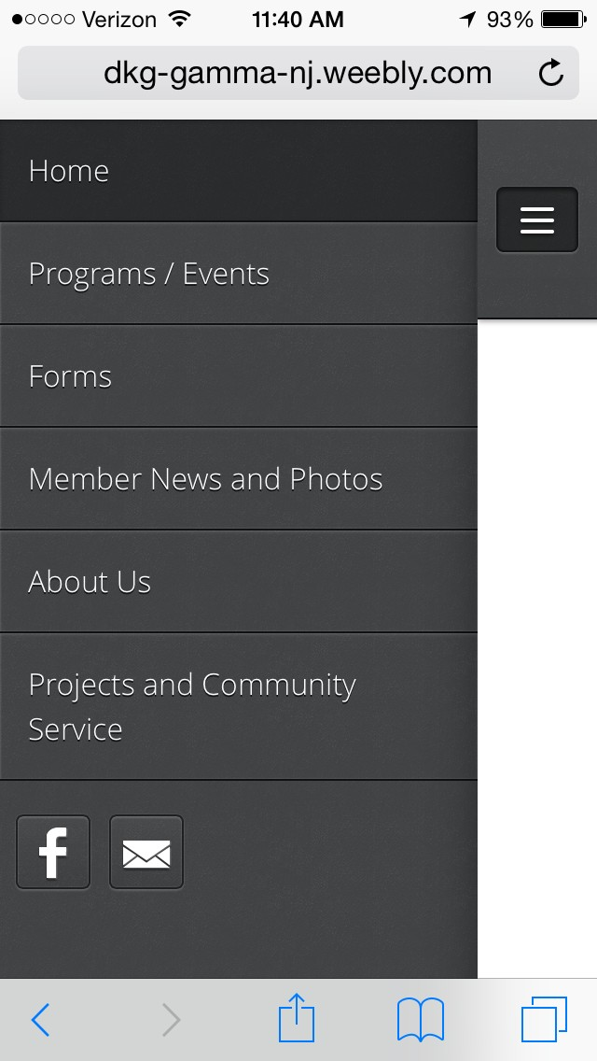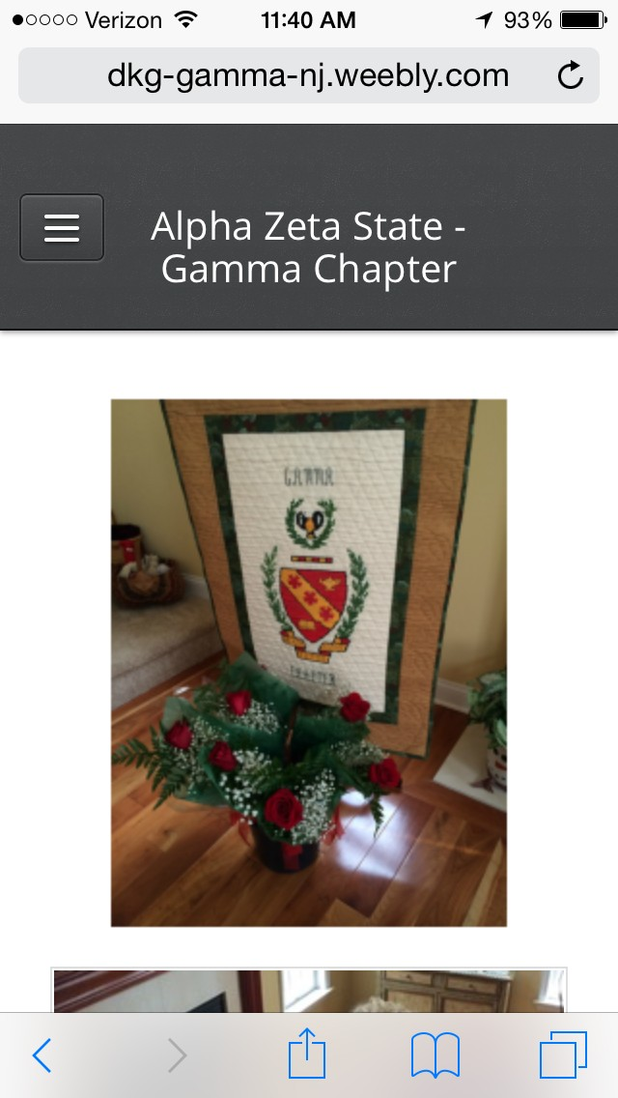

1. Go to Gamma

Chapter Homepage

2. On left side, select menu icon and click programs and events.

Menu Icon

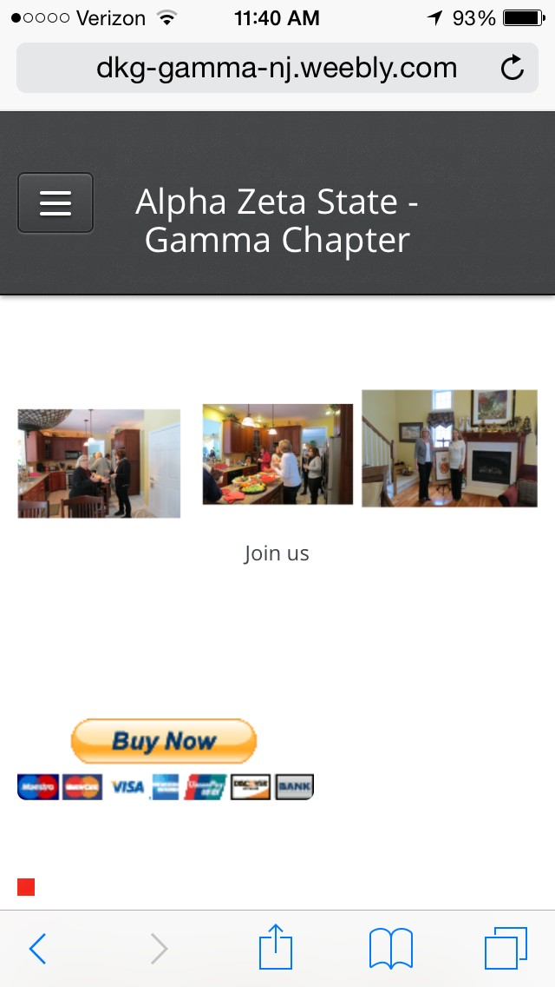

3. Select Buy Now

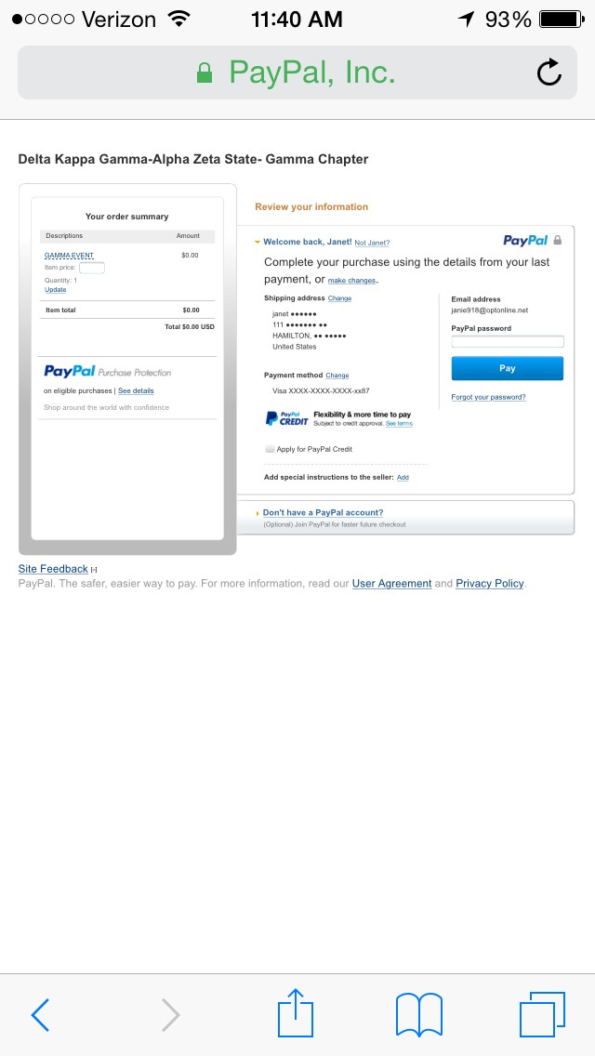

1. Key in the amount you are paying.
2. In “Add special instructions to the seller, insert the reason for payment. (i.e. .dues, October Event.)